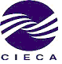 No. 55 / January 2017
CIECA News Letter

Monthly Event Summary
The Luncheon for the Canadian Parliamentary Delegation on January 9 th, 2017
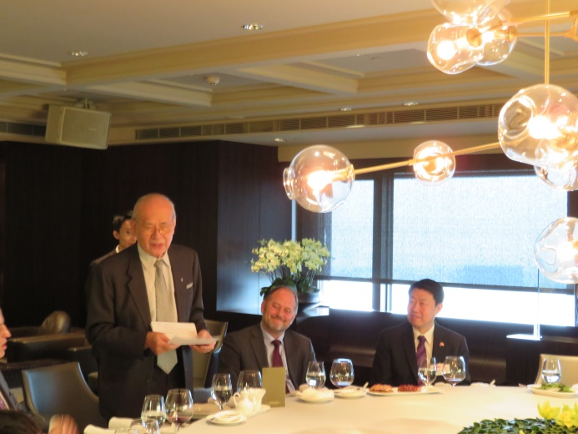
Vice Chairman Fred P.C. Huang (standing) delivers his welcome remarks.
At the invitation of CIECA, the Canadian Parliamentary Delegation led by Mr. Hon. Pierre Poilievre (MP) visited Taiwan from January 9 th to 15 th. The delegation includes Mr. Nicola Di Iorio (MP), Mr. Bob Saroya (MP), Mr. Michael Cooper (MP), Ms. Shannon Stubbs (MP), and their family members. The delegates were interested in Taiwan’s democratic, social and economic development, diplomatic and cross-strait relations, bilateral economic relationship between Taiwan and Canada, along with the development on Taiwan’s technology, agriculture, environmental protection, green energy industry, education, culture and congress. Upon their arrival on January 9 th, Vice Chairman Fred P.C. Huang hosted a luncheon at the Taipei World Trade Center Club in honor of the delegation.
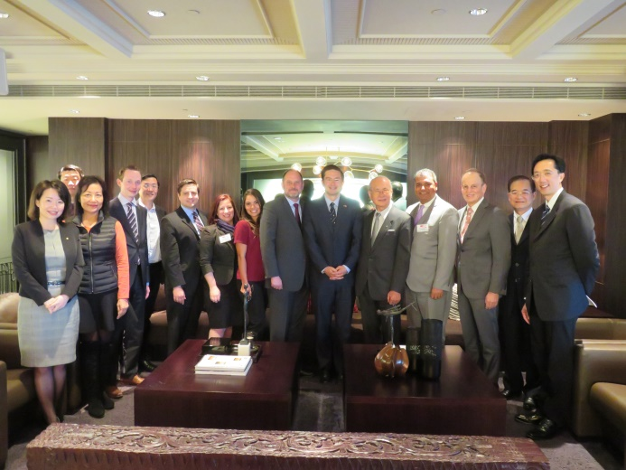
Group photo of the Luncheon for the Canadian Parliamentary Delegation

Dinner for Mr. Musawenkosi Aphane, Representative of Liaison office of the Republic of South Africa, hosted by Jeff Sun, Vice Chairman of CIECA on Jan. 23, 2017.
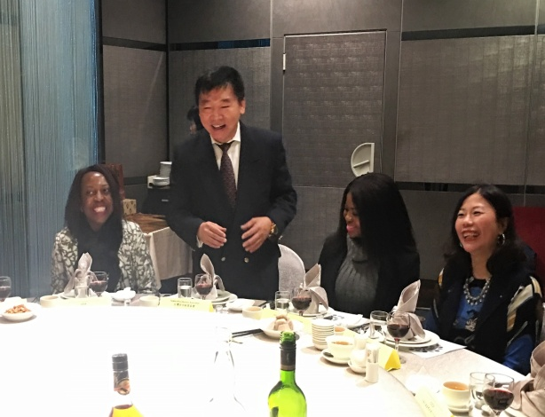
Ms Sibongile Mabasa, Deputy Representative (leftmost) and Ms Lorato Legotlo (2nd from right), Third Secretary Corporate Service of Liaison office of South Africa, attend the dinner hosted by Mr. Jeff Sun, Vice Chairman of CIECA
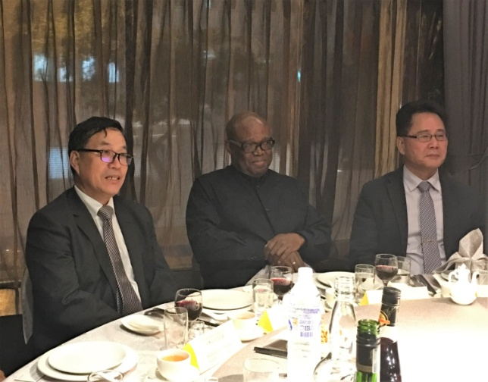
Mr. Musawenkosi Aphane, Representative of Liaison office of the Republic of South Africa; Mr. T. T. Hsiao (left), Deputy Executive Director of Taiwan-Africa Trade Promotion Office and Mr. Hank Hsieh (right), Vice Chairman of TABA

 |  | 2017 CIECA Tentative Event Plan (Europe)
No | Date |  | Events | Venue
1 | March 23 |  | The 20th Joint Conference of Spain-Taiwan Business Cooperation Committee | Madrid, Barcelona
2 | March 27 |  | The 5th Taiwan-Portugal Joint Business Council Meeting | Lisbon, O Porto
3 | April 19 |  | The 5th Joint Business Forum Sofia-Taipei | Sofia
4 | March- April  (TBC) |  | The 7 th Joint Meeting of Taiwan-Turkey Business Council | Taipei
5 | April  (TBC) |  | The 6th Finland-Taiwan Joint Business Council Meeting | Taipei
6 | May  (TBC) |  | The 6th Meeting of Taiwan-Italy Joint Business Council | Taipei
7 | June 12-13  (TBC) |  | The 23rd Netherlands-Taiwan Joint Business Council Meeting | Amsterdam
8 | June-August  (TBC) |  | The 13th Taiwan-Hungary Joint Business Council Meeting | Taipei
9 | June 21  (TBC) |  | The 16 th Session of the Taiwan-Czech Joint Business Council | Taipei
10 | October-November |  | The 10th Taiwan-Austria Economic Cooperation Conference | Taipei
11 | September-November |  | The 19th Taiwan-Belgium Joint Business Council Meeting | Taipei
12 | September  (TBC) |  | The 6th Russia-Taiwan Business Forum | Moscow
13 | September  (TBC) |  | The 15th Poland-Taiwan Joint Business Council Meeting | Warsaw
14 | September-November |  | The 17th Taiwan-Germany Joint Business Council | Taipei
15 | September 26  (TBC) |  | The 33rd Sweden-Taiwan Joint Business Council Meeting | Stockholm
16 | September-November |  | The 2nd Switzerland-Taiwan Joint Business Council Meeting | Swiss
17 | November  (TBC) |  | The 10th Taiwan-Luxembourg Joint Business Council Meeting | Taipei
18 | April-November  (TBC) |  | The 5 th Estonia-Taiwan Business Forum | Tallin
19 | April-October  (TBC) |  | The 2nd Croatia-Taiwan Joint Business Council Meeting | Zagreb
20 | May-November  (TBC) |  | The 1st Denmark-Taiwan Joint Business Council Meeting | Copenhagen
21 | May-October  (TBC) |  | The 5th Latvia-Taiwan Joint Business Council Meeting | Riga
22 | May-November  (TBC) |  | The 18th Joint Meeting of Taiwan-Britain Business Council | London
23 | May-November  (TBC) |  | The 2nd Ireland-Taiwan Joint Business Council Meeting | Dublin

 |  | 2017 CIECA Tentative Event Plan (Non-European Areas)
No | Date |  | Events | Venue
1 | February-June |  | 2017 Investment Delegation to Guatemala, Honduras, El Salvador, Nicaragua, The Dominican Republic. | Guatemala,Dominica, Honduras,Salvador, Nicaragua
2 | February-June |  | 2017 Investment Delegation to Saint Vincent and the Grenadines, Saint Kitts and Nevis, Saint Lucia, Belize. (TBC) | Saint Vincent and the Grenadines, Saint Kitts and Nevis, Saint Lucia, Belize
3 | January-June |  | The 21st Joint Economic Cooperation Conference between Taiwan and Indonesia | Taipei
4 | January-June |  | The 17 th Taiwan-India Joint Business Councils Meeting | Taipei
5 | March-June |  | The 16th Malaysia-Taiwan Joint Economic Conference | Kuala Lumpur
6 | March-September |  | The 14 th Joint Meeting between CIECA and SBF | Singapore
7 | March-October |  | The 23 th Conference of the Taiwan-Saudi Joint Committee for Economic & Technical Cooperation | Taipei
8 | April-October |  | The 2nd Joint Meeting of CIECA and CCC | Phnom Penh
9 | April-October |  | The 21st Joint Business Council Meeting between CIECA and VCCI | Hanoi, HCM
10 | May-August |  | The 7 th Taiwan-Israel Joint Business Council Meeting | Taipei
11 | June-November  (TBC) |  | The 1st Taiwan-Sri Lanka Joint Business Council Meeting | Taipei
12 | September |  | The 31st CACCI Conference | Sydney
13 | September 19-21 |  | The 10 th World Chamber Congress | Sydney
14 | September-October |  | The 31 st Joint Conference of the ROC-Australia and ATBC | Brisbane
15 | September- December |  | The 16th Joint Meeting between CIECA and MNCCI | Taipei
16 | September- December |  | The 24 th Joint Meeting of Philippine-Chinese and Chinese-Philippine Business Councils | Manila
17 | September- December |  | The 42nd Joint Conference of ROC-Korea and Korea-Taiwan Business Councils | Seoul
18 | November |  | The 26 th Joint Economic Cooperation Conference between CIECA and FTI | Bangkok

